The load testing of the service <http://104.199.15.101:80/api/return_eu_countries> is done using Jmeter.

**Observations:**

The load testing is done for 75 users with 350 concurrent connections for 60 mins.

Total number of executions: 433368

Throughput achieved: 120.4/sec

Average elapsed time in milliseconds: 622

Median: 524

Error %: 0.00%

Received Kb/sec: 33.25

Sent kb/sec: 27.15

The load testing is done successfully with 0% error, but the average response time should be under 200ms. And it is imperative from result that it didn’t meet the expected criteria of under 200ms mark.

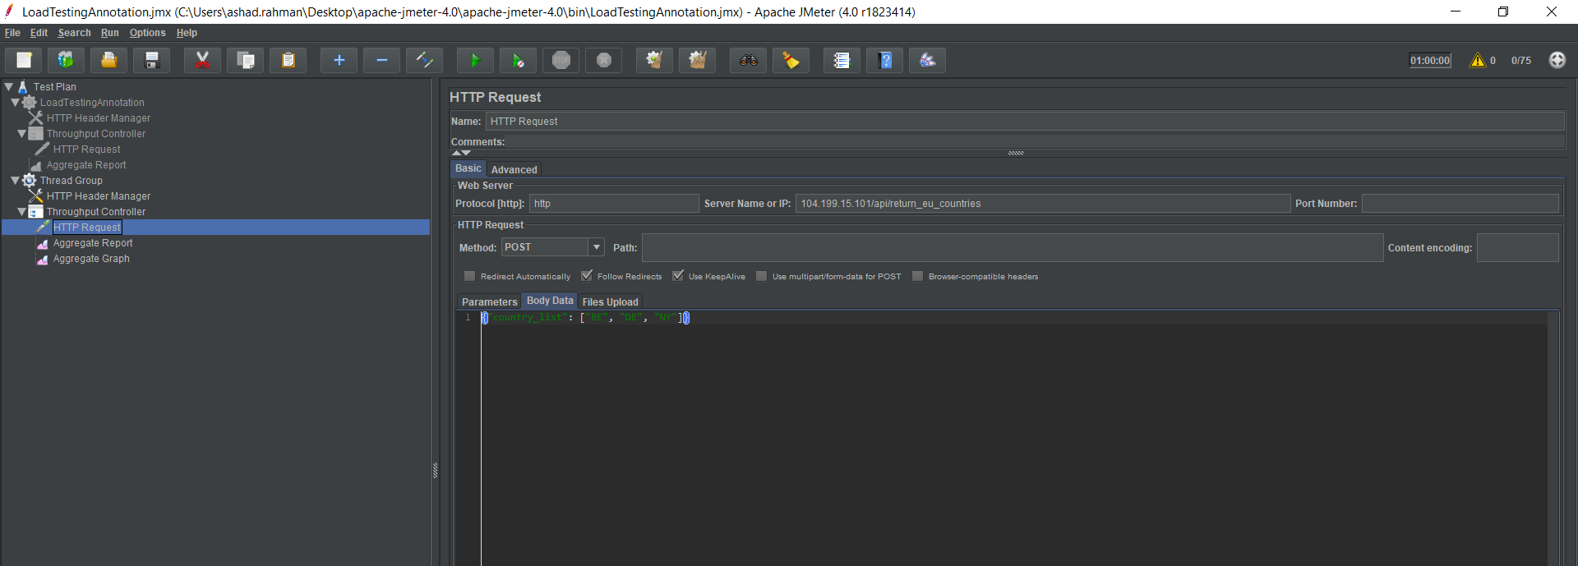

Aggregate Report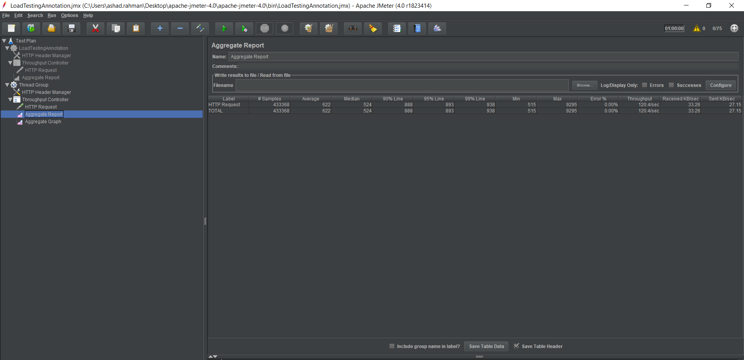

Aggregate Graph

